Ash Class Curriculum Letter
Hello,
Welcome back, we have a busy rest of the spring term ahead! Miss Gemma will continue to cover Ash Class on a Friday and I will be working Monday to Thursday as normal. As always, if you have any queries please do not hesitate to contact me in school, dojo message or email me at your earliest convenience.
Kind Regards,
Miss Moore
mmoore@fleetwoods.lancs.sch.uk

Literacy  This half term we will be focusing on the text ‘Sam and Dave dig a hole’. We will continue to use Jane Considine loosely but will be putting a heavier focus onto reading this half term and really understanding the texts. We will also focus on different stories through other areas of the curriculum. We will also be using a dictionary so the children will become familiar with what a dictionary is and how we use them effectively.  Phonics  Reception:  This half term we will continue Phase 3 phonics which is where the children will be learning the rest of the digraphs that create sounds, these are two letters that join together to make a specific sound, for example ‘sh’. It is really important you read as often as possible with your child so they can progress through their book bands and practice reading books that match their phonic ability, if your child has not been reading regularly they will be struggling to remember the digraphs that are being taught.  Year 1:  Year 1 will be continuing with phase 5 so they are as prepared as possible for the phonics screening in June. All pupils in year 1 need to be reading as often as possible to give them the best chance to achieve age related expectations in reading. | Ash Class  Newsletter Spring 2  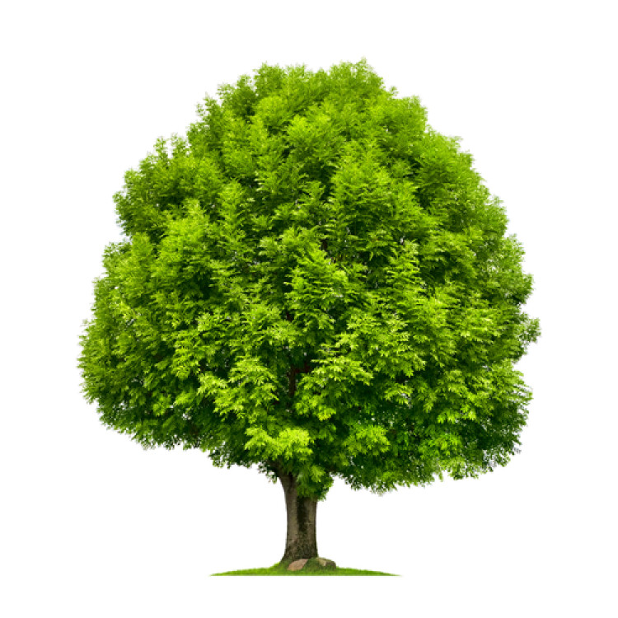 |  | Maths  In Year 1 this half term we will be focusing on place value within 50 and learning all about length, height mass and volume. This will be taught very practically.  In reception we will be learning about the concept of time, length and height and 3D shapes. Alongside these units we will continue working on numbers within your child’s capabilities whether that be to 5, 10, 15 or beyond!
 | RE  This half term our RE focus is ‘What Made Jesus Special?’ this will be being taught by the PGCE student Miss McBrine who is with us until the week before we break up for Easter. |  | PE/Physical Development  This half term Year 1 will have PE with the rest of year 1 and the year 2 pupils taught by coach Ryan from Fleetwood Town football club on a Monday afternoon whilst reception pupils are in the forest.  Miss Gemma will then teach another PE session to the whole of Ash class on a Friday afternoon and this half term it will continue to be Dance for the first couple of weeks and will then move onto another unit.
Science/History/Geography/Computing  EYFS: Understanding the World  In Science we will be learning about seasonal changes and will focus on ‘Spring’, we will also be finishing off our animal unit learning about carnivores, herbivores and omnivores and will continue looking at plants/planting. Please keep an eye on the wild flowers that your child planted in school and encourage your child to look after them so they grow!  In History we will be studying local history and our focus is the history of the school. We will be comparing the school from when it was first built to now. We will be doing this because Geography took up the whole of last half term so this was not covered last half term.  Miss McBrine the PGCE student will be teaching Computing to year 1 focusing on Pictograms using Purple Mash that the children are now very familiar with. |  | Forest School  Forest School sessions will be on a Monday afternoon for Reception pupils each week. Please ensure your child has forest clothes and wellingtons in school  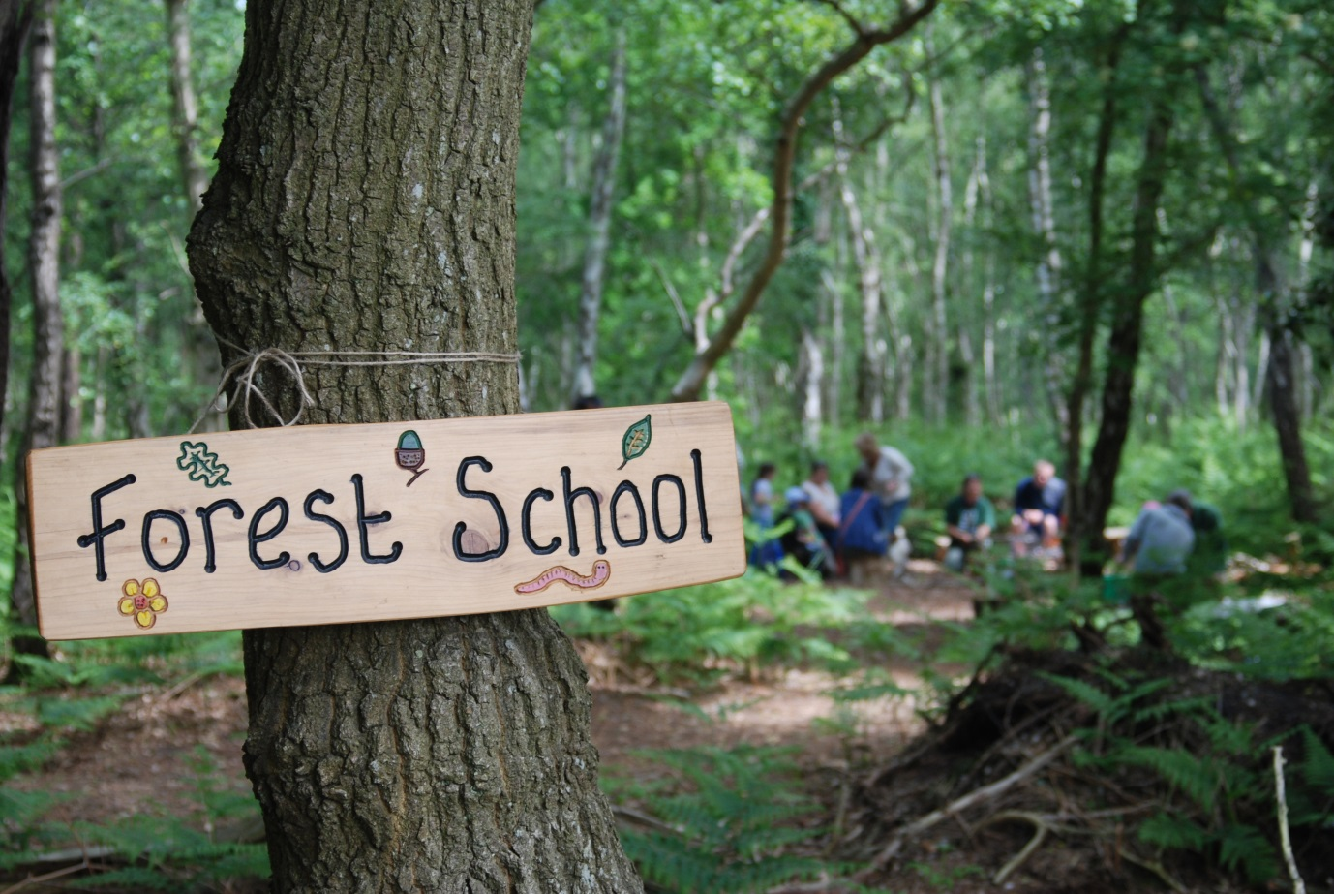 | Homework  The home learning menu for your child is attached to this newsletter. These are activities linking to all areas of learning this half term and have been chosen as a fun home/school link.
PSHE  This half term Miss Gemma will teach PSHE to reception pupils on a Friday and Year 1 will have their session on a Thursday afternoon, this is so the pupils get the appropriate sessions for their age group.  Year 1  Harold's wash and brush up  Around and about the school  Taking care of something  Harold's money  How should we look after our money?  Basic first aid  Reception  Looking after my special people  Looking after my friends  Being helpful at home and caring for our classroom  Caring for our world  Looking after money (1): recognising, spending, using  Looking after money (2): saving money and keeping it safe |  | Art/DT/Music  EYFS: Expressive Arts and Design  In Art we will be looking at Collage, we will be making our own collages by exploring with different materials and we will also be looking at famous artists who specialise in Collages.  In Music Miss Gemma will be using the Charanga scheme of music ‘Round And Round, a Bossa Nova Latin style.’ which will focus on singing and playing musical instruments. | EYFS: Communication and Language  Re tell stories that are familiar to them, some as exact repetition and some using their own words. Learn rhymes poems and songs and listen and talk about selected non-fiction to develop a deep familiarity with new knowledge and vocabulary.
Areas of Provision
The reception pupils will have access to the areas of provision both inside and out all day each day and will complete small adult led activities. There will be challenges and enhancements in the areas and there will always be a mixture of free play and adult initiated tasks.
Year 1 will have opportunities throughout the day to use the areas of provision but they will have more focused tasks to complete within them.
Some of the areas will be changed daily (creative, maths, literacy, water tray) and some will be the same but will have enhancements through adult questioning/set tasks to complete. It is equally important for children to use some of the areas freely to develop their own imagination and work with their peers.

