Ash Class Curriculum Letter
Welcome back, I hope you have all had a lovely Christmas and a good start to the New Year. We have a very busy half term ahead of us which is detailed below.
If you have any queries please contact me in school, via Class Dojo or by my email:
mmoore@fleetwoods.lancs.sch.uk

English  This half term we will be focusing on the book ‘The Aliens are coming’. We will be learning the book by heart and performing it in Assembly. On Monday’s Mrs Gladwin will be teaching reading/writing skills appropriate to the children’s academic abilities.  Phonics/Spelling  The children in Year 1 will begin Phase 5 Phonics  Reception children will begin Phase 3 phonics. | Ash Class  Newsletter Spring term 1  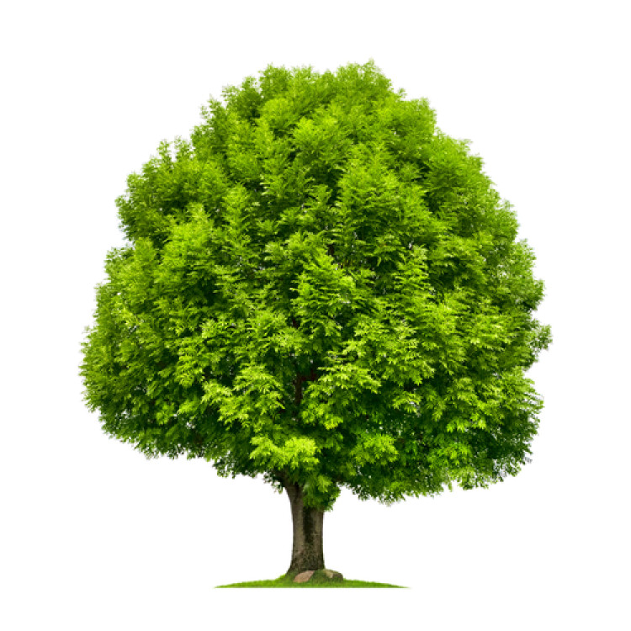  To Infinity and Beyond! |  | Maths  We will be continuing our work on place value and numbers within 100 (varied depending on children’s academic abilities)/. We will also be looking at 2D/3D shapes, comparing and learning to measure mass/weight and also to continue recognising coins and begin to realise the value of different coins in everyday life.
 | RE  Mrs Gladwin will be teaching this subject every Monday. This half term the focus is Stories that Jesus heard. |  | PE  This half term our PE slot is Thursday afternoons where we will be  Science  We will be learning about Planets, light sources and why travelling to outer space needs lots of preparation to keep ourselves alive (freeze dried food, oxygen etc.)
Topic  We will be looking at Space which will include learning all about Yuri Gagarin, planets, food in space, the Sun as a light source and will also be using junk materials to make our very own Rocket! We will have a junk modelling station for the children to use during their free choice time so please send in any reusable junk you have- bottles, milk tops, small boxes, kitchen roll tubes etc. |  | Forest School  Forest School sessions will be on Friday afternoons. Please ensure your child has forest clothes and wellingtons in school.  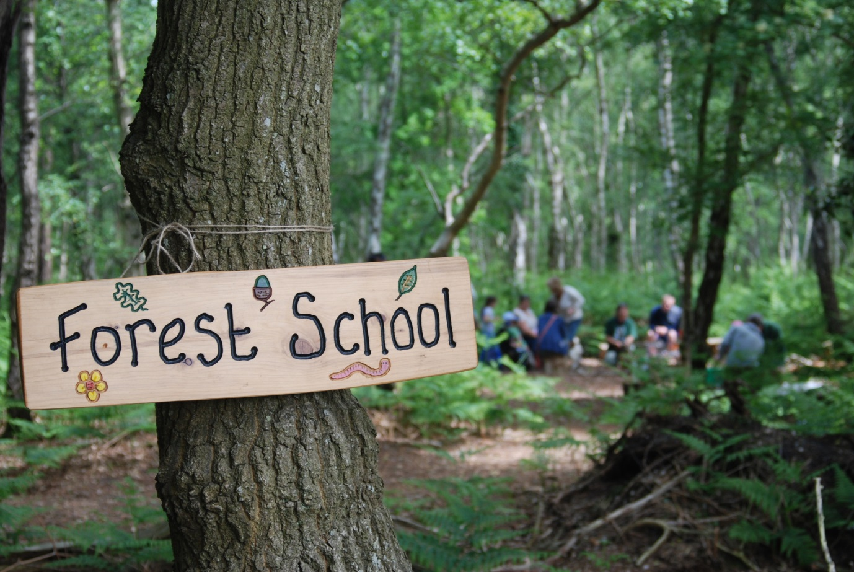 | Homework  I will be sending home learning logs next week (w/b 13.1.20)
PSHE

Mrs Gladwin will be teaching this subject every Monday using the plans from ‘SCARF’ who run the Life Education Bus that the children visit each year. The lessons focus on Harold the Giraffe which the children have met earlier on in the school year when we visited the Life Education bus. If your child didn’t attend then they will have been introduced to him in a PSHE lesson.

This half term I have set up a junk modelling station so the children can design their own spaceships/space crafts. Please help keep up the stock of junk by bringing in any junk that you would otherwise be recycling – lids, cardboard boxes, plastic bottles, cartons, yogurt pots, foil, cling film etc.

Thanks,
Miss Moore

