Ash Class Curriculum Letter
Hello,
I hope you have all had a lovely Christmas and a Happy New Year. This half term I will be teaching Monday- Thursday in Class and Miss Gemma will be teaching some foundation subjects on a Friday. I will be tutoring some of the pupils in year 1 on a Friday morning. As always, if you have any queries please do not hesitate to contact me in school, dojo message or email me at your earliest convenience.
Kind Regards,
Miss Moore
mmoore@fleetwoods.lancs.sch.uk

Literacy  This half term we will be focusing on the text ‘The snail and the whale’ written by Julia Donaldson. We will complete lots of activities to help us to understand the story, we will change parts of the story to develop our imaginative skills within story and we will be retelling the story through the use of small world play. This story also lends itself to rhyming words so we will spend some times focusing on them alongside looking at some seasonal poetry.  Phonics  Reception:  This half term we will be beginning Phase 3 phonics which is where the children will be learning the rest of the individual sounds (j,v,w,x,y,z) as well as digraphs that create sounds, these are two letters that join together to make a specific sound, for example ‘sh’. It is really important you read as often as possible with your child so they can progress through their book bands and practice reading books that match their phonic ability, if your child has not read much in the autumn term so therefore isn’t picking up pace segmenting and blending then they will not be able to move onto books that contain digraphs which will in turn result in them forgetting the digraphs being taught.  Year 1:  We will be continuing to revisit phase 3 sounds alongside starting phase 5. This is important as all year 1 pupils will have their phonics screening check in June and without any awareness of phase 5 phonics they cannot access the screening check. | Ash Class  Newsletter Spring 1  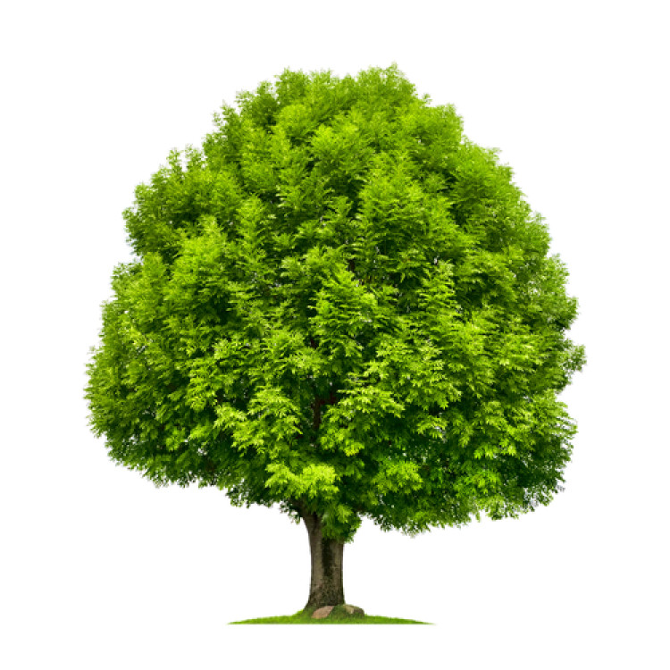 |  | Maths  In Year 1 this half term we will be focusing on place value within 20 and addition and subtraction within 20. This will be alongside mastering numbers within 10 for those children who need some more practice.  In reception we will be learning about mass and capacity as well as length, height and time. We will also be working on numbers within 10 over the spring term to make sure the children are confident with recognition, ordering, 1 to 1 correspondence and addition and subtraction.
 | RE  This half term our RE focus is Easter where we will be learning about the Christian meaning of Easter. |  | PE/Physical Development  This half term Year 1 will have PE with the rest of year 1 and the year 2 pupils taught by coach Ryan from Fleetwood Town football club on a Monday afternoon whilst reception pupils are in the forest.  Miss Gemma will then teach another PE session to the whole of Ash class on a Friday afternoon and this half term it will be Dance.
Science/History/Geography/Computing  EYFS: Understanding the World  In Science we will be learning about plants and animals. We will be beginning to look at the structure of different plants and planting our own plants to observe over the spring as well as learning about different animals; identifying them and learning what animals are carnivores/herbivores/omnivores.  In History we will be studying local history and our focus is the history of the school. We will be comparing the school from when it was first built to now.  In Geography we will be looking at the United Kingdom compared to Antarctica, using google maps and globes to find both areas on a map. |  | Forest School  Forest School sessions will be on a Monday afternoon for Reception pupils each week. Please ensure your child has forest clothes and wellingtons in school  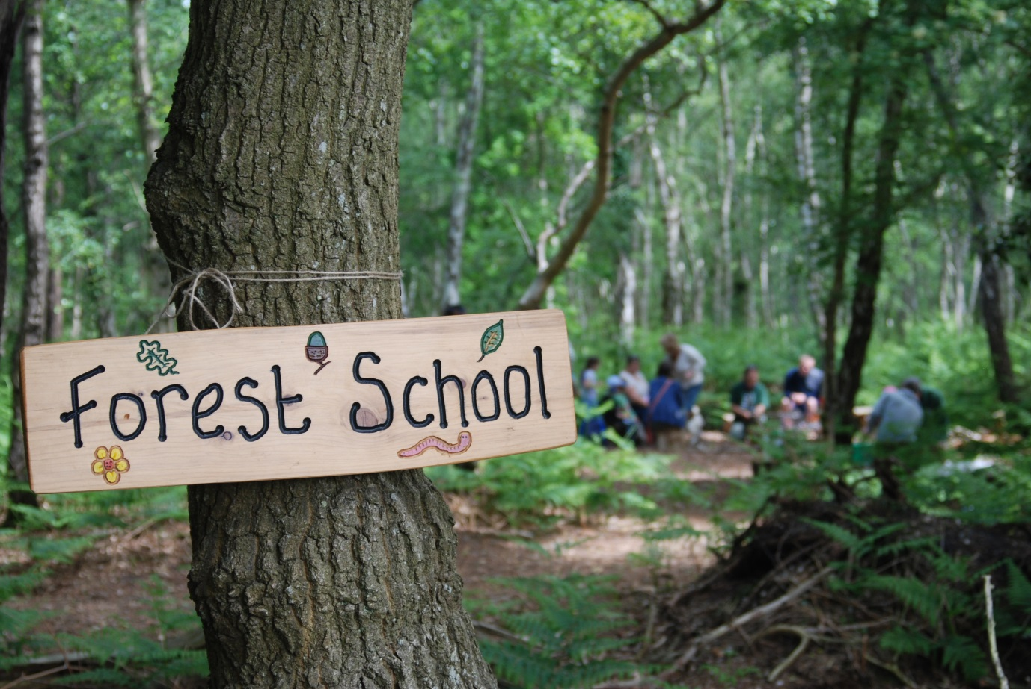 | Homework  The home learning menu for your child is attached to this newsletter. These are activities linking to all areas of learning this half term and have been chosen as a fun home/school link.
PSHE  This half term Miss Gemma will teach PSHE to reception pupils on a Friday and I will teach it to year 1 on a Monday afternoon, this is so the pupils get the appropriate sessions for their age group.  Year 1  Healthy me  Super sleep  Who can help? (1)  Harold loses Geoffrey  What could Harold do?  Good or bad touches?  Sharing pictures  Reception  What's safe to go onto my body  Keeping Myself Safe - What's safe to go into my body (including medicines)  Safe indoors and outdoors  Listening to my feelings  Keeping safe online  People who help to keep me safe |  | Art/DT/Music  EYFS: Expressive Arts and Design  In Art we will be looking at 3D art where we will be exploring sculpture, manipulating malleable materials and creating materials for a purpose.  In Music Miss Gemma will be using the Charanga scheme of music ‘In the Groove’ which will focus on different styles of music. | EYFS: Communication and Language  Ask questions to find out more and check that they understand what has been said to them.  Listen and talk about stories to build familiarity and understanding.  Retell a story that has been read to them.
Areas of Provision
The reception pupils will have access to the areas of provision both inside and out all day each day and will complete small adult led activities. There will be challenges and enhancements in the areas and there will always be a mixture of free play and adult initiated tasks.
Year 1 will have opportunities throughout the day to use the areas of provision but they will have more focused tasks to complete within them.
Some of the areas will be changed daily (creative, maths, literacy, water tray) and some will be the same but will have enhancements through adult questioning/set tasks to complete. It is equally important for children to use some of the areas freely to develop their own imagination and work with their peers.

