Welcome to Oak Class
Welcome back, I trust you have all had an amazing Christmas and New Year. We have a very busy, short half term ahead which is detailed below. Please support your child at home by asking questions about their school day, listening to your child read, reading to your child and assist them with homework.
If you have any concerns, please come in to see us or contact us via email or Dojo, sclarkson@fleetwoods.lancs.sch.uk mwells@fleetwoods.lancs.sch.uk
Kind regards
Oak Class team
English  Stories by the same author  The children will listen to and discuss stories by Julia Donaldson. The children will make predictions and use drama techniques to retell the stories. Children will explore the features of Julia Donaldson’s stories.  Non-chronological Reports  The children will be taught how to use the features of reports to write their own.  Phonics/Spelling  The children will continue to develop their phonics and spelling knowledge. Year 2 will continue to follow No Nonsense Spelling scheme whilst Year 1 get to grips with Phase 5 phonics. | Oak Class  Newsletter Spring 1  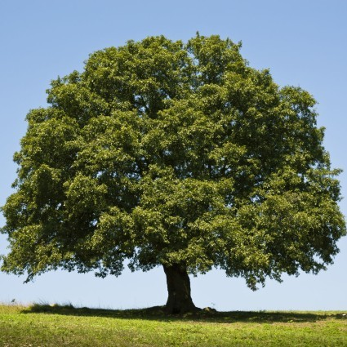 | Maths  This half term we will revisit place value. The children will use their knowledge of place value in the context of measures. They will further develop their understanding of multiplication (2, 3, 5 and 10) together with division.  In addition, the children will be comparing objects of different mass, converting between grams and kilograms and reading scales. They will also be looking at the properties of 2d and 3ed shapes.
RE
Jesus, friend to everyone
Children will investigate these key questions.
What is a miracle? Why did Jesus welcome everyone? I wonder how it felt to meet Jesus? What did Jesus want us to learn from his behaviour? What do the stories we listen to in this unit reveal about Jesus?
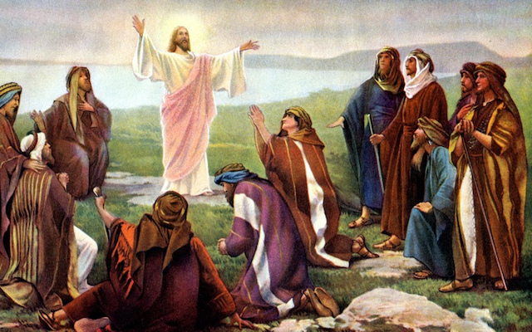
History  Explorers  In this unit, children will be finding out the answers to these questions.  What does the word ‘explorer’ mean? What does an explorer do, and what tools, equipment and essential items might they need for their journey? Are there any famous explorers that used similar equipment?  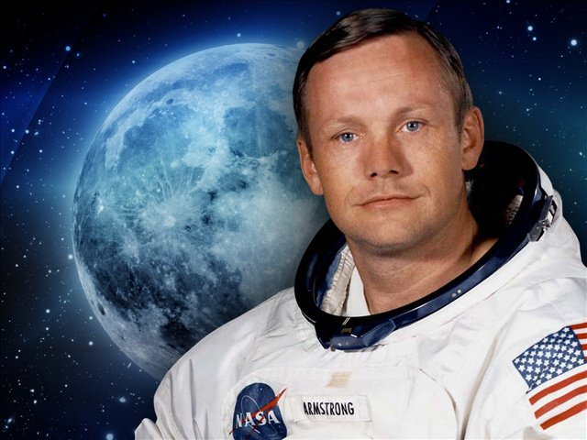 | Computing  The children will be looking at how the program a vehicle to negotiate a route. | PE  Yoga/  PE lessons will be on Mondays and Thursdays. If your child wears earrings please ensure they are removed for the said days. If your child can remove their own prior to the lesson this is acceptable.  On a Monday the children will be taught Yoga by a Fleetwood Town Community Trust coach. Yoga uses breathing techniques, exercise and meditation. It helps to improve health and happiness.  On Thursdays the children will be looking at ways to travel, roll and balance, before using these to create a routine.
Geography  In this unit, children will learn about a small area within a contrasting non-European country. Children will explore similarities and differences between the small area being studied and areas with which they are more familiar. | DT  The children will be researching, designing and making wheeled vehicles, using a range of materials and techniques. | Music  This half term the children will be learning how to play a glockenspiel.  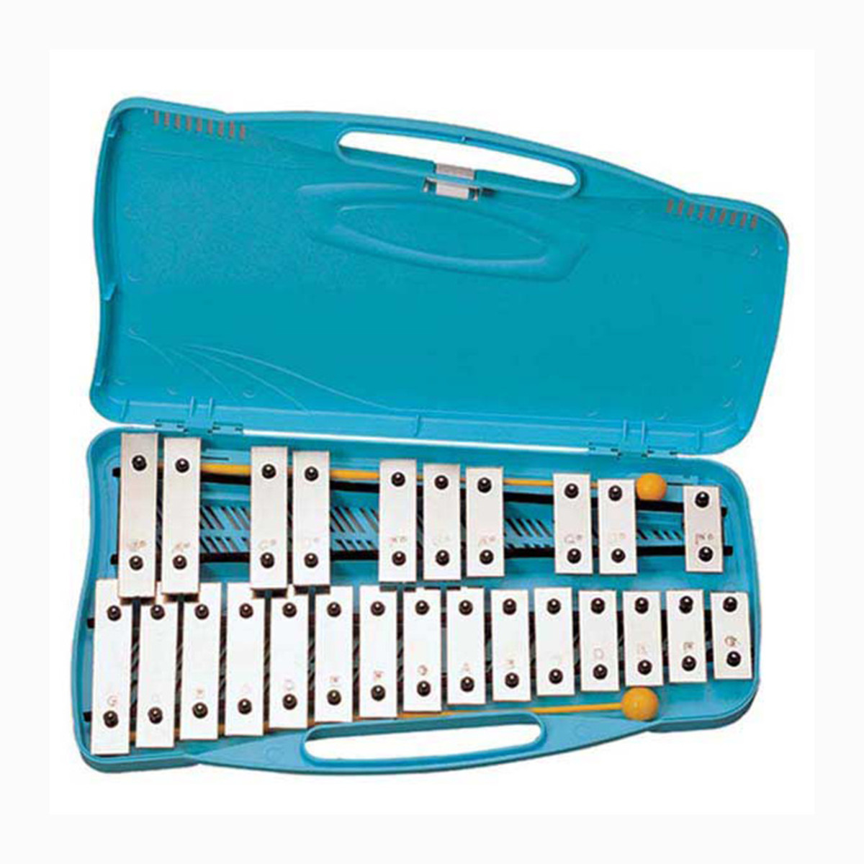
Class Dojo
Thank you to those parents who have already signed up to the Class Dojo site. You will be aware that it states Mrs Clarkson’s Classroom. However, as you know Mr Wells is also the Class Teacher. The system wouldn’t allow two teacher names!
It is a great way for us to keep you updated with day to day classroom life and also for you to send messages and pictures to share. If you have an urgent message please ring the office as we may not be available to check the Dojo messages.

