Ash Class Curriculum Letter
Welcome back, I trust you all have had a fabulous break. We have a very busy half term ahead of us which is detailed below.
If you have any queries please contact me in school, via Class Dojo or by my email:
mmoore@fleetwoods.lancs.sch.uk
sclarkson@fleetwoods.lancs.sch.uk
English  This half term we will be comparing fiction and non-fiction books. We will be writing and following simple instructions in a variety of ways. We will also be creating simple fact files of our favourite.  Phonics/Spelling  The children in Year 1 will continue Phase 4 phonics.  Reception children will continue Phase 2 phonics with plenty opportunities to practise new skills in our Learning Areas. | Ash Class  Newsletter Autumn Term 2  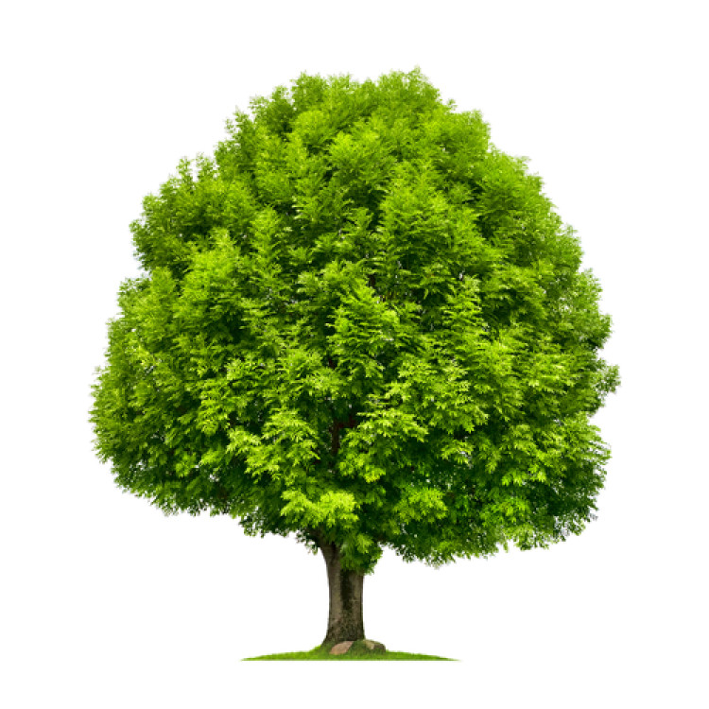  Now and Then |  | Maths  This half term we will start by continuing repeating patterns. We will then move on to simple factions, capacity and volume using lots of practical activities to develop understanding. We will also learn about money and time.  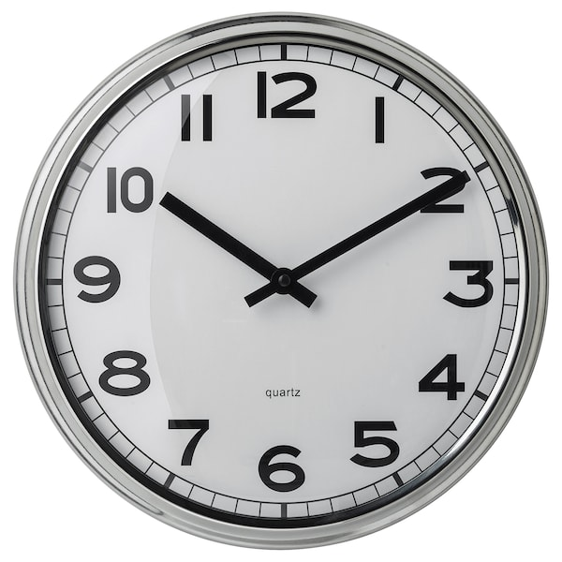
 | RE  Our unit this half term is ‘Celebrating Christmas – How do we celebrate Jesus’ birthday?’  We will discuss the different ways in which we celebrate the birthdays of people of all ages. We will listen to the ‘Nativity Story’ and the children will take part in our KS1 ‘Hosanna Rock’ production.  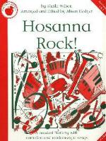 |  | PE  This half term our PE slot is moving to Wednesday afternoons. The children will be taught dance by Miss Gemma.  Science  We are investigating Seasonal Changes.  We will begin discussing the seasons and changes then focus more on weather setting up our own weather station. We will link our art to this topic creating trees for each season.
Topic  We will be looking at old and new toys, houses, clothes and also looking at Blackpool now compared to how it looked 100 years ago. |  | Forest School  Forest School sessions will be on Friday afternoons. Please ensure your child has forest clothes and wellingtons in school. Also as the weather gets colder please ensure that they bring in warm clothing, hat gloves etc.  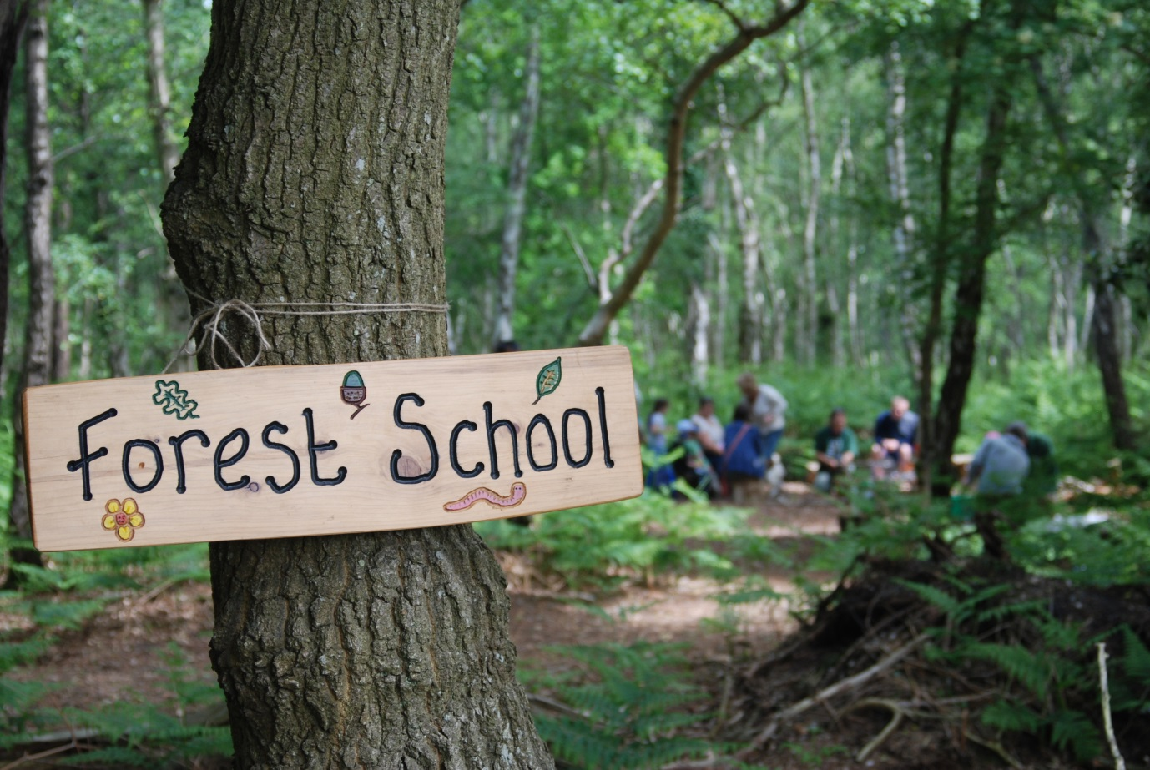 | Homework  Your child will bring home a homework sheet. Please don’t feel you have to complete all the activities or do them all at once. It is better if you spread the activities out.  Please continue to read to your child and listen to them read as often as possible.  If you would like a book for your child’s homework then please let us know.

