Ash Class Curriculum Letter
Hello,
I hope you have all had a lovely half term break and your children are feeling rested ready for a very busy half term leading up to Christmas! We have chosen our EYFS and KS1 Nativity so scripts will come home this week. All children have an important role in the nativity but most of them are acting parts rather than speaking roles, it is still important for your children to become familiar with the story and practise the songs (once they are familiar with the tune when they have learnt them in school to the music).
As always if you have any queries/concerns please do not hesitate to contact me via dojo, email or before/after school.
Kind Regards,
Miss Moore
mmoore@fleetwoods.lancs.sch.uk

Literacy  We will be focusing on the text ‘We’re going on a bear hunt’ and ‘What we’ll build’. For this we will be using the Jane Considine scheme but will be using lots of discussion tasks around both books to encourage a love for reading!  Phonics  Reception:  This half term we be continuing with Phase 2 Phonics which is where your child will be continuing to learn new sounds and learning how to segment/blend for reading simple CVC words. We will also learn some ‘trick words’ which are words that are not phonetically decodable such as the, to, I, go, no and my.  The sounds taught so far; s,a,t,p,i,n,m,d,g,o,c,k,e,u, r, h.  Year 1:  Some of us will be continuing with phase 5 phonics and the rest of us will be continuing and completing phase 3 phonics. | Ash Class  Newsletter Autumn 2  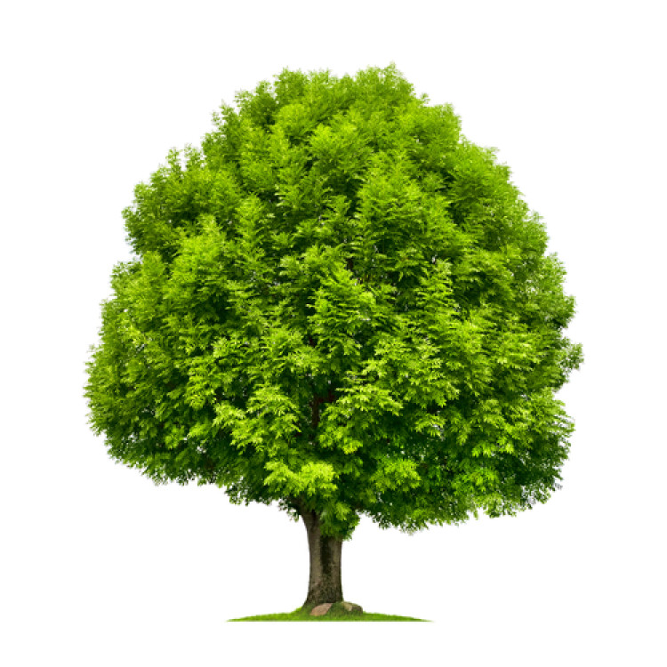  What and why do we celebrate? |  | Maths  Reception:  This half term we will be focusing on numbers within 5 and learning about 2D shapes and their properties. The small steps for these units will be subitising, representing numbers to 5, 1 more and 1 less than and identifying and recognising shapes in the environment.  Year 1:  This half term we will be focusing on addition and subtraction within 10/20 and learning about shapes. The small steps this half term are part whole models, fact families within 10, writing number sentences, systematic number bonds within 10, addition problems, subtraction, and subtraction on a number line. We will then move onto recognising and naming properties of 2D and 3D shapes.
 | RE  Mrs Potter will teach RE to the reception children on a Friday morning.  This half term the focus will be on The Christmas Story. |  | PE/Physical Development  This half term we will have our PE slot on a Tuesday afternoon and our other physical development slot will be in the forest on a Friday afternoon.  We will be linking our PE session to space where we will learn different ways to travel and move our body.
Science  In Science we will be learning about materials and their properties. We will be completing lots of experiments and learning about which materials are best to use for particular jobs.  Art and Design  This half term Mrs Potter will teach Art on a Friday morning and the focus will be mixing colours and textures. The children will learn what primary and secondary colours are and how to make different colours using the primary colours. |  | Forest School  Forest School sessions will be on a Friday afternoon for all pupils each week. Please ensure your child has forest clothes and wellingtons in school  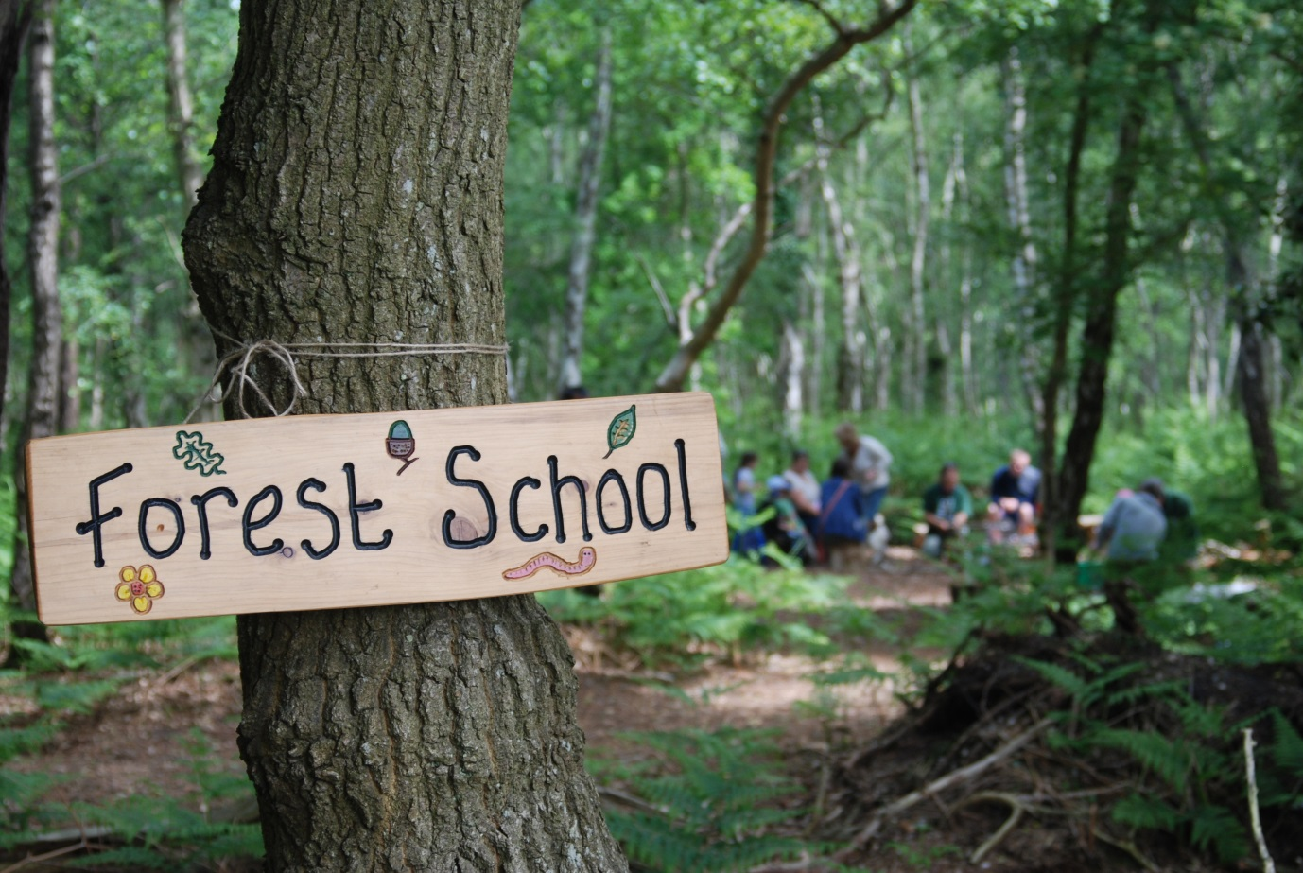 | Homework  This half term each pupil will receive a extended learning menu. It is a lovely way to get involved with what your child is learning in school.  Please complete as many tasks as possible and allow your child to bring in their work to show to the rest of the class.  Most of the activities will be practical and fun so your child will enjoy completing them at home in their own time. Please send homework in as and when over the half term but no later than Thursday 7th December.
PSHE/ PSED  This half term in PSHE we will be focusing on:  Reception  I'm special, you're special  Same and different  Same and different families  Same and different homes  I am caring  I am a friend  Year 1  Same or different?  Unkind, tease or bully?  Harold's school rules  Who are our special people?  It's not fair! |  | Music  EYFS: Expressive Arts and Design  In Music we will be using our whole school scheme and the unit is called ‘Rhythm in the way we walk and banana rap’. | EYFS: Communication and Language  Engaging in stories beyond their reading ability.  Listening and discussing what we notice about songs and rhymes.  Engaging in non-fiction books.  Learning and using new vocabulary.

