Welcome Back
Welcome back. I hope you all had a fantastic Christmas and I wish you all a Happy New Year. As always, we have a busy half term ahead of us and I trust the children are refreshed and ready to work hard.
Homework will be given out on a Friday and is to be returned the following Wednesday.
Our PE lessons are on Tuesdays (Year 4s swimming) and Fridays so please ensure your child’s PE kit is in school and earrings are removed before school.
If you have any concerns please come in to see us or email me, sclarkson@fleetwoods.lancs.sch.uk
Kind regards
Willow Class Team
English  Story as a Theme  Children will listen to and discuss the story Stig of the Dump by Clive King. The children will identify the main events, characters and setting. We will use drama to take on the role of a character using evidence from the text. By the end of the unit the children will be able to write a narrative based on a plot.  Grammar focus: Prepositions within sentences and inverted commas for dialogue.  Discussion  Children will use their knowledge from other subjects and discuss whether they would prefer to live in the Stone Age or present day. | Willow Class  Newsletter  Spring 1  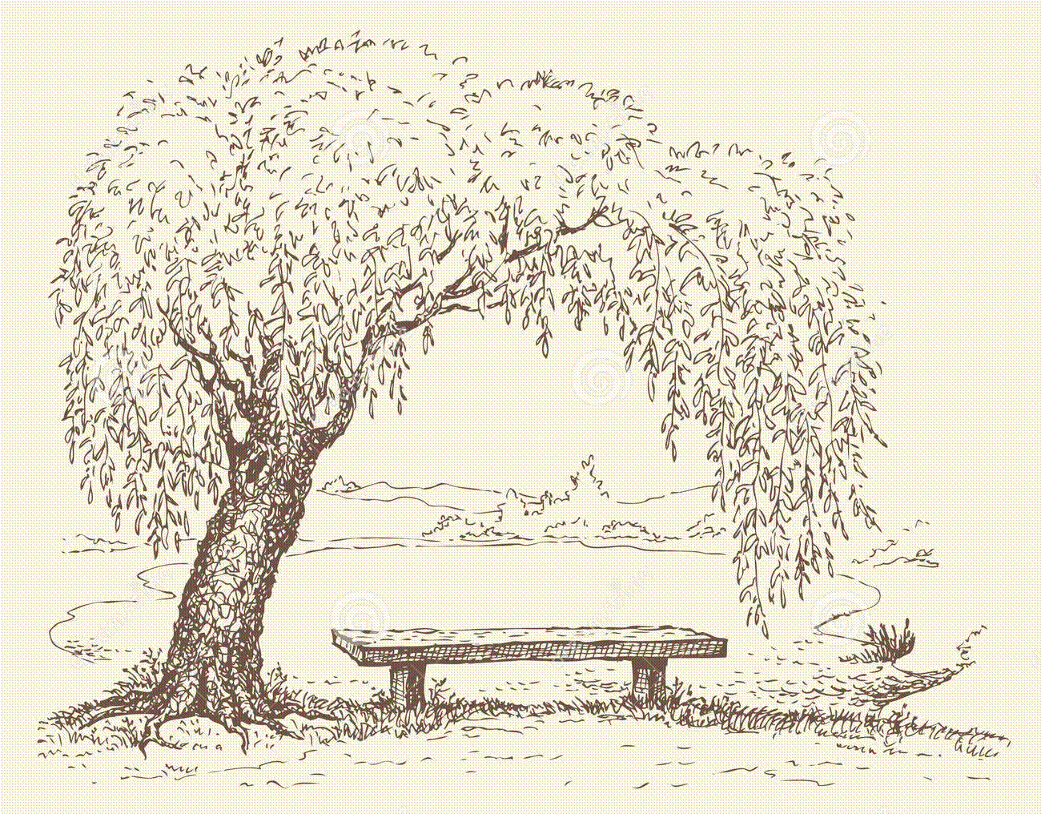  Rock and Roll | Maths  This half term we will begin by investigating number sequences. Children will further develop their understanding of fractions, capacity, written and mental multiplication, pictograms and working with money.  Forest School Sessions  This half term Year 4 will join Mrs Crompton for Forest School Sessions. These will take place on Friday mornings starting on Friday 8th January. Children should come to school in their Forest School clothes and bring their uniform in to change at lunchtime.
RE

Jesus the Man who Changed Lives
This half term the children explore how Jesus changed lives studying stories from the Bible.

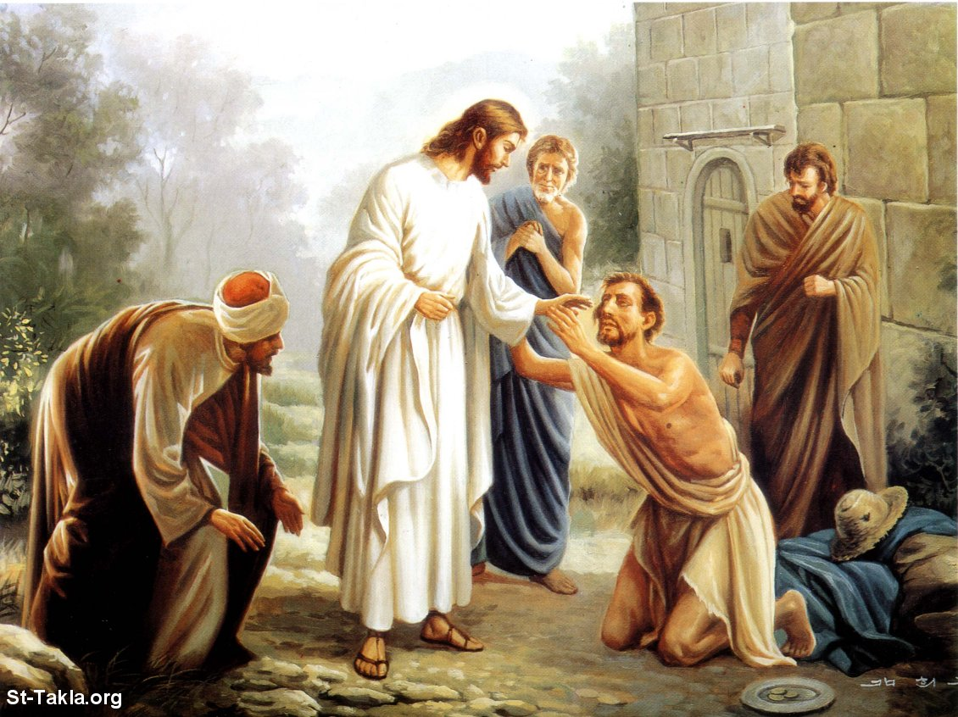

Computing
This half term the children will develop their research skills using search engines. They will also continue to learn how to stay safe online.
Music  Rock and Roll  The children will listen to and appraise a variety of rock and roll songs. We will look at the history of rock and roll and consider the effect artists such as The Beatles and Elvis Presley had on the music industry. The children will compose their own new lyrics to the melody of a popular rock and roll song. | Science  Rocks  During this topic the children will compare, sort, classify and group together different kinds of rocks and describe in simple terms how fossils are formed. They will investigate rocks and soils through observations. We will all become rock detectives investigating what can change the appearance of rocks. | PE  Gymnastics  The children will continue to develop their Gymnastic skills this half term.  Dance  We are extremely lucky this half term to have The Blue Moose Dance Company coming into school to teach the children a Rock and Roll unit.
History  Ancient Britain  During this topic the children will learn about early settlements including farming and hunting.  We will also research Stongehenge and significant buildings created at the same time elsewhere in the world.  Geography  Earthquakes and Volcanoes  In this theme, children will investigate earthquakes and volcanoes: what they are; why they happen and how they affect the landscape and human activity. They will learn that the earth is constantly moving and changing, inside and on the surface.   | PSHCE  Me and My Relationships  This theme is the second of two focusing specifically on feelings. It explores feelings within the context of our important relationships including family and friends. The theme aims to develop knowledge, understanding and skills in three key social and emotional aspects of learning: self-awareness, managing feelings and empathy.  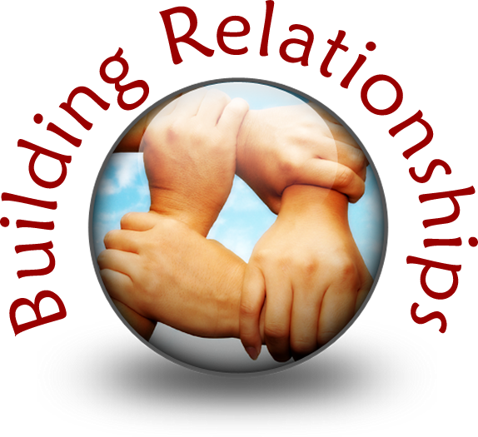 | ART  Printmakers  Children will explore the work of printmakers such as Eric Gill and Japanese printmakers using different printmaking methods such as woodcut. Children will also investigate the drawings of fossils made by palaeontologists such as Robert Hooke in the 1700s.  

