Welcome to Willow Class
Welcome back, I hope that you have all had a lovely Summer break. We have a busy half term ahead which is detailed below. Please support your child at home by asking questions about their school day, listening to your child read, reading to your child and assisting with any homework.
Reading through this together will help to prepare your child for their learning this half term.
If you have any concerns, please come in to see me or contact me via email or Dojo, noxley@fleetwoods.lancs.sch.uk
Kind regards
Mrs Oxley
English  The wolves in the walls  This half term we will focus our English learning around the suspense narrative-The wolves in the walls.  We will develop our punctuation, sentence type and structure. We will also be developing our descriptive language such as similes.  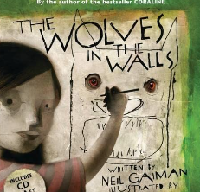  Spelling  We will continue to develop our phonics knowledge and will continue learning different spelling patterns, applying these in our writing. | Willow Class  Newsletter Autumn 1 |  | Maths  In maths this half term we will begin by developing our place value knowledge. We will be learning about numbers up to 1000 and how we can represent, write and show these amounts. We will be completing part whole models and developing our understanding of number when working with larger quantities.  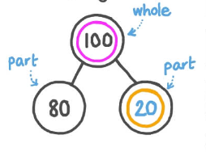  During the final few weeks of Autumn 1, we will begin an addition and subtraction unit.  We will apply our place value knowledge when adding and subtracting 2 and 3 digit numbers. We will progress this learning further by crossing 10s and 100s when adding.
RE
Harvest

We will be exploring the meaning of Harvest, looking at the ways in which communities celebrate harvest around the world and deepening our understanding of why harvest is celebrated by people of all faiths and world views.

Science  In our science lessons this half term we will be learning all about electricity. We will be creating simple electric circuits as well as learning about electrical safety. We will also learn about conductors and insulators. | Computing  During Autumn 1, we will learn about coding and online safety. |  | PE  Willow class will have two PE sessions a week.  X1 with Coach Ryan on a Wednesday focusing on dance.  X1 on a Thursday focusing on gymnastics.
Geography  In geography this half term we will be learning about different types of energy. We will learn about renewable and non-renewable energy and will gain an understanding of how these energy types are sourced and the impact they have on our planet. | DT  This half term in DT we will be using and applying our science knowledge when forming structures including electricity. We will design, make and evaluate 3D mask sculptures including lights and/or sounds such as buzzers. |  | Music  Our learning will be focused around one song called ‘Let Your Spirit Fly’. We will be learning the song, playing musical games, learning about the pulse, rhythm and pitch, singing and playing some instruments.
Class Dojo  Class Dojo is a great way for me to keep you updated with day to day classroom life and also for you to send messages and pictures to share.  If you have an urgent message or a message regarding attendance, please ring the office as we may not be available to check the Dojo messages during the school day. |  | Reading  Your child will soon bring a reading book home which is to be enjoyed together. Each time that your child has completed their reading book, they can bring them into school to be changed-so every school day if you choose. Reading at home will support your child’s learning and will help to reinforce their phonics knowledge too.  Similarly, to when your child was in Oak class with myself, children will receive a stamp each time they read at home. Once 10 stamps have been collected, they get to choose a prize from the class goody box!

