Welcome Back
Welcome back, I trust you have all had a lovely summer break. We have a busy half term ahead which is detailed below.
Homework will be given out on a Friday and is to be returned the following Wednesday.
We will be swimming on Tuesdays and our other PE lesson will be on a Friday so please ensure your child’s PE kit is in school by this Friday.
If you have any concerns, please come in to see me or email me, sclarkson@fleetwoods.lancs.sch.uk
Kind regards
Willow Class Team
Literacy  Roald Dahl  The focus this half term will be the expressive use of rich language to convey characters, stories, rhymes and humour.  Using his shorter stories and rhymes – namely, The Enormous Crocodile, George’s Marvellous Medicine, The Twits (the book and the play) and Revolting Rhymes – we will focus strongly on creative writing and expressive speech, with many opportunities for children to discuss Dahl’s rich characters and plots and also present their own variations. | Willow Class  Newsletter Autumn 1  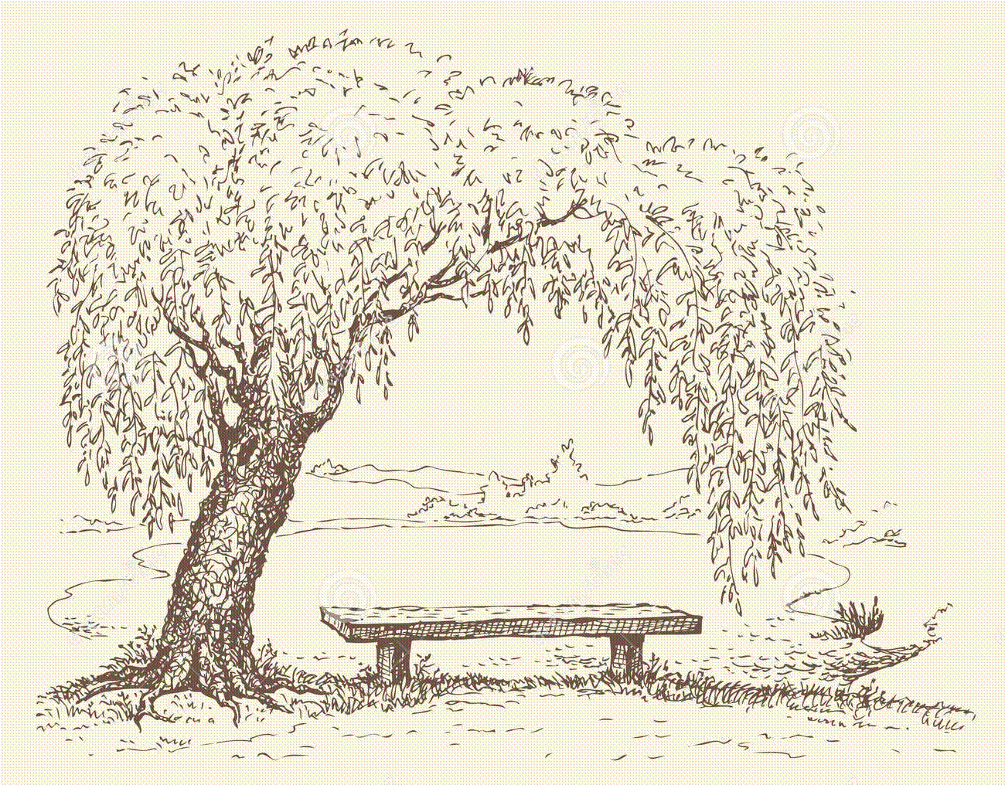 | Maths  This half term we will cover place value and mental calculation, 2D shape and length including perimeter, statistics and mental calculation, written addition and written subtraction methods.  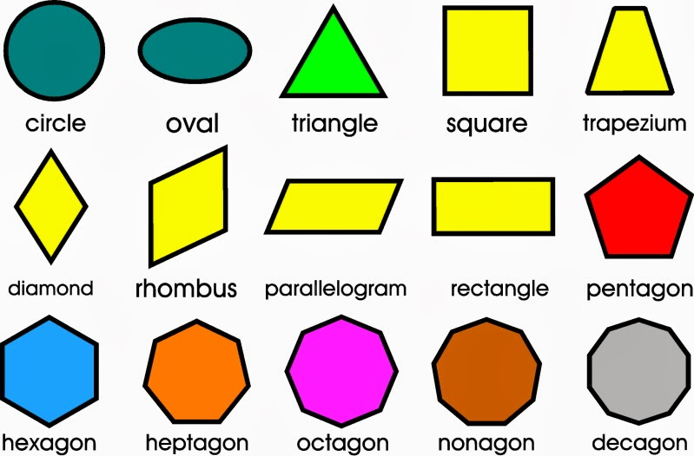
RE
God, David and The Psalms
During this unit children will discuss the Stories of David, contribute to class discussions about the important values including friendship. Study stories of Christians overcoming the ‘Goliaths’. We will read the Psalms and using the words and images, explore the nature of God. The children will then have the opportunity to write their own Psalms.
Science  Electricity  The children will begin the unit identifying which appliances use electricity and learn how to stay safe around electricity.  We will investigate and make a variety of circuits to include cells, bulbs, switches, motors and buzzers.  We will also investigate conductors and insulators. | Computing  We will begin this unit of work by recapping on internet safety.  Children will learn programming using the Scratch Program. They will  design, write and debug programs that accomplish specific goals, including controlling or simulating physical systems; solve problems by decomposing them into smaller parts. | PE  Swimming  The children will be swimming on a Tuesday morning at YMCA Poulton. Please ensure that your child brings a costume/trunks (tight short trunks are acceptable) and a towel. They may also bring a snack for when we return to school.  Invasion Games  Children will learn to send and receive a ball, move and pass, along with travelling with a ball. The children will then apply their skills in a game situation. We will revise simple tactics and evaluate our own and others’ success.
DT  Using skills developed in our science lessons, the children will design, make and evaluate a buggy. The buggy will consist of a chassis complete with axles and wheels, an electric motor, battery, switch and a transmission system so that the electric motor can make the vehicle move forward in a straight line. They will also develop a card body shell. Wish me luck!  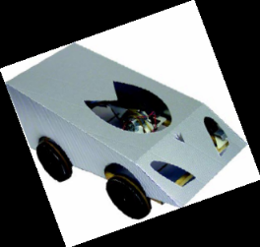 | PSHCE  Changes  Children will consider some ways in which change is positive, developmental and necessary. They will consider the many changes that have happened in their own lives and their feelings in relation to these changes. They will know that a  degree of apprehension about change is normal  and that humans have a range of strategies for  coping flexibly with it. Children’s coping strategies will be elicited and extended. Children will have the opportunity to make a plan to change an aspect of their behaviour, and learn  that we cannot make other people change, we can only change ourselves. They will explore the importance of belonging and how change can threaten this. They will have opportunities to  explore feelings and responses to unwelcome or  imposed change. They will think about the links  between feelings, thoughts and behaviours and deepen their self-awareness and empathy with others as a result. | Music  Mamma Mia  During the course of this unit the children will learn:  - How to listen to music  - To sing the song  - To understand the geographical origin of the music and in which era it was composed  - To experience and learn how to apply key musical concepts/elements eg. finding the pulse, clapping a rhythm and use of pitch  - To play the accompanying instrumental parts and work together in a band/ensemble  - To develop creativity through improvising and composing with the song  - To understand and use the pentatonic scale while improvising and composing  To recognise the style of the music and to understand it’s main style indicators

