Ash Class Curriculum Letter
Hello, I hope you are enjoying the lovely weather. The last half term of Reception, time flies! This half term is where I will be gathering evidence and having a final push to get the best possible out of each child. They have all come on in leaps and bounds and I am so proud of them all, for very different reasons! It is amazing when I look through their folders as see how far we have come as a cohort since September last year, I hope you feel the same. Below is a breakdown of what we will be learning until July.

As always please do not hesitate to contact me if you have any queries at all.
You can contact me in school, via Class Dojo or by email:
mmoore@fleetwoods.lancs.sch.uk

Literacy  This half term we will be beginning an official Jane Considine Literacy unit focusing on a story alongside practising and learning skills that are essential for developing your child’s English abilities ready for year 1.  The focus texts will be ‘The rainbow fish’ and ‘The snail and the Whale’.  Phonics  This half term we will be finishing off Phase 3 and completing Phase 4. Miss Brakewell will continue to have an extra phonics group with those children who need to revisit some of the sounds we have already learnt. Please encourage your child to read as much as possible at home as well as building words involving the digraphs we have been learning. The ones we have learnt so far are sh, qu, ch, th, ng, ai, ee, igh, oa and oo, ar, or, ur, ow, oi and ‘ear’. | Ash Class  Newsletter Summer 2  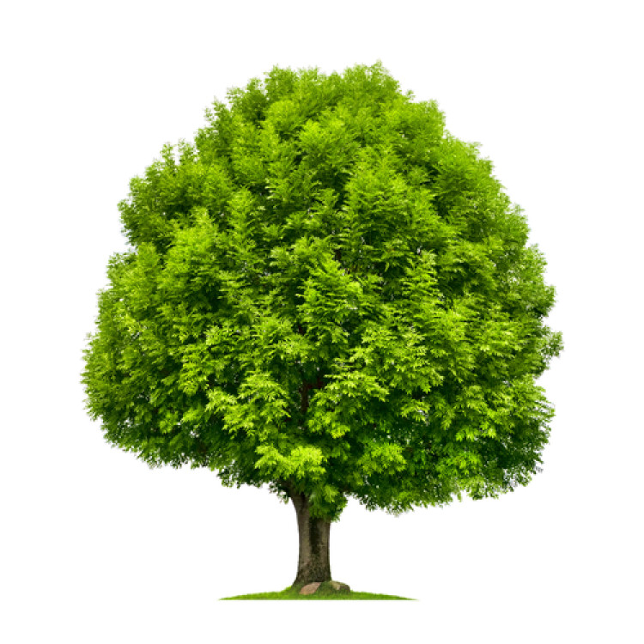  At the Seaside |  | Maths  This half term we will be introducing numbers beyond 10 as well as consolidating numbers within 10. The focus areas will be;  *Build numbers beyond 10  *Count patterns beyond 10  *Doubling  *Sharing and grouping  *Odd and Even  *Patterns and relationships  *Spatial Mapping
 | RE  Mrs Potter will teach RE to the reception children on a Friday morning. |  | Physical Development  This half term we will be continuing learning multi skills which are all of the gross motor basics ready to progress into year 1. This half term we will be making sure each child practices any areas of fundamental skills that they may find tricky. We will do as many PE sessions as we can outside to make the most of the lovely weather (hopefully).  We will also have plenty of activities in our classroom and outdoor area to develop our fine and gross motor skills which will be a huge part of our provision.
Understanding the World  We will be exploring the season of Summer. We will also be learning lots about the seaside; the history of the seaside (now and then), animals that live by/under the sea, seaside towns and comparing underwater animals to animals on land. |  | Forest School  Forest School sessions will be on a Friday afternoon. Please ensure your child has forest clothes and wellingtons in school  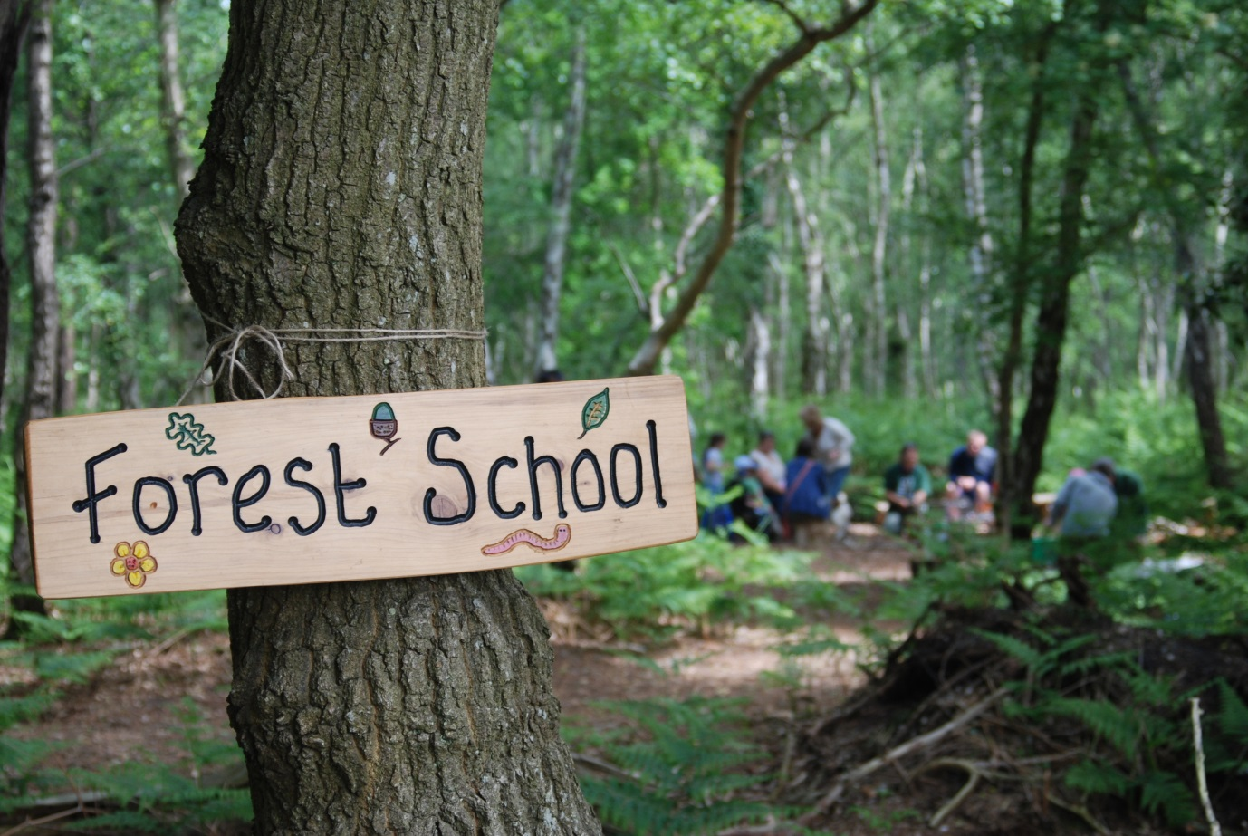 | Homework  The home learning menu will have come home with this newsletter, it is also on the Ash Class page on our school website ☺
PSHE/ PSED  This half term in PSHE we will be focusing on:  * Life stages- humans, plants and animals  *Me and my body  *Getting bigger  *Where do babies come from? |  | Expressive Arts and Design  We will be inventing and adapting stories through small world and role play.  As always there will be ever-changing activities in our creative area which will allow the children to practise the skills they have been learning this year. | Communication and Language  We will be focusing on speaking in full sentences using correct vocabulary. We will also be responding to and discussing different texts as well as making sure we are constantly enhancing our vocabulary.

